View Response
Response Details
From
Hazel Dawe
Date
Started: 19 Dec 2020 12:12. Last modified: 19 Dec

2020 12:12
Status
Complete
Response ID
#879918

1
In which role are you responding to this survey?

Please tick all that apply.
If Other, please specify
Cowley Area Transport Group www.catg.org.uk
I am a resident
I represent / own a local business
I represent a voluntary and community services (VCS) organisation
I represent another stakeholder e.g. parish council, health, police etc.
I am an employee of Oxford City Council
I am a council tenant
Other

2
Approach to Budget Setting
The City Council’s approach to setting it’s Budget and Medium Term
Financial Strategy includes a number of elements which are listed below.
Other organisations undertake alternative approaches to this exercise
To what extent do you agree or disagree with the
City Council approach
set out below?
Select the most applicable option in each row.

Strongl
y Agree
Agree
Neutral
Disagre
e
Strongl
y
Disagre
e
Using our wholly owned
company, Oxford Direct
Services Ltd to generate
more income from external
trading
Using our wholly owned
company Oxford City
Housing Ltd to develop
social and market housing
Increase council tax by the
maximum level permitted
% per year) to
(1.99
safeguard services
Reduce office space and
remote working by admin
staff
Go cashless- withdrawing
the ability to pay for council
services by cash and cheque
in favour of card, electronic
banking or Paypoint
Use balances and reserves
to meet one-off costs of the
pandemic
Maintain current service
levels and continue to
support with annual
efficiencies and increased
fees and charges
Please enter any additional comments
Approach to Budget setting: We reject the idea of using Council funds for
developing market housing as prices in Oxford are too high. We support
using the existing built environment for social and keyworker housing.
We do support using part rent/part buy options for keyworker homes.
The overall approach does not specify building homes around, above or
right over Oxford's private and public car parks. This is critical for
reducing car commuting inside Oxford, and from outside, and offering
people the opportunity to live near to workplaces within Oxford.
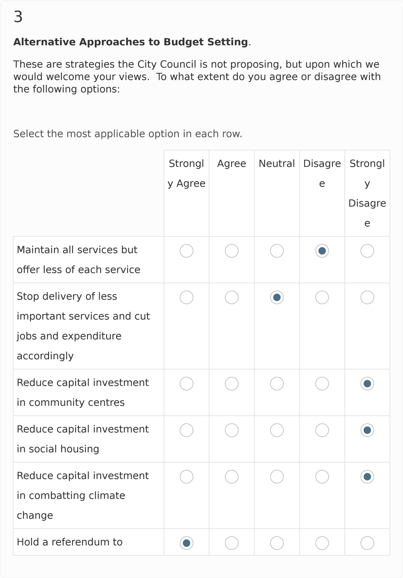
consult on increases in
council tax above the 1.99%
cap
Freeze Council Tax and cut
services
Please enter any additional comments
:
All investment must ensure that the Climate and ecological impacts of
any new or refurbished development should be minimal, preferably in
construction and not just in operation.
4

Our Priorities
In terms of meeting its overall objective of ‘Building a World Class City for
Everyone’ the Council’s key aims are to:
•
Enable an inclusive economy
:
Council staff are skilled and confident
in delivering services our residents want and the workforce as a whole
better reflects Oxford’s diverse population; The Council’s supply chain
supports more local businesses, including social enterprises and
cooperatives, promoting wider benefits to the local economy
•
Deliver more, affordable housing
:
The Council have increased the
supply of high quality, energy efficient housing with a balanced mix of
homes for sale and to rent at different price points; The Council’s
Blackbird Leys regeneration delivers high quality homes and a better
use of space; More Council and private sector tenants are supported to stay in their homes where they face the prospect of eviction
- Support thriving communities: The Council’s services, grants, community and leisure facilities, parks and cultural events have helped reduce inequality, increase cohesion and improve health and wellbeing across Oxford’s communities; Children and young people’s resilience and confidence is increased through the educational and recreational activities we offer; The Council’s public spaces remain clean, safe, well maintained and are more accessible
- Pursue a zero carbon Oxford: The City Council making significant progress on the journey to reduce its own carbon footprint to zero; all new buildings by the Council progressing towards near or net-zero carbon standards; The Council’s existing council housing is being made more energy efficient.
How would you rank the priority of the following services:
Select the most applicable option in each row.
Very High Mediu Low Very
High Priority m Priority Low
Priority Priority Priority
Provision of affordable housing
Tackling Climate Change
Preventing homelessness
Providing and supporting
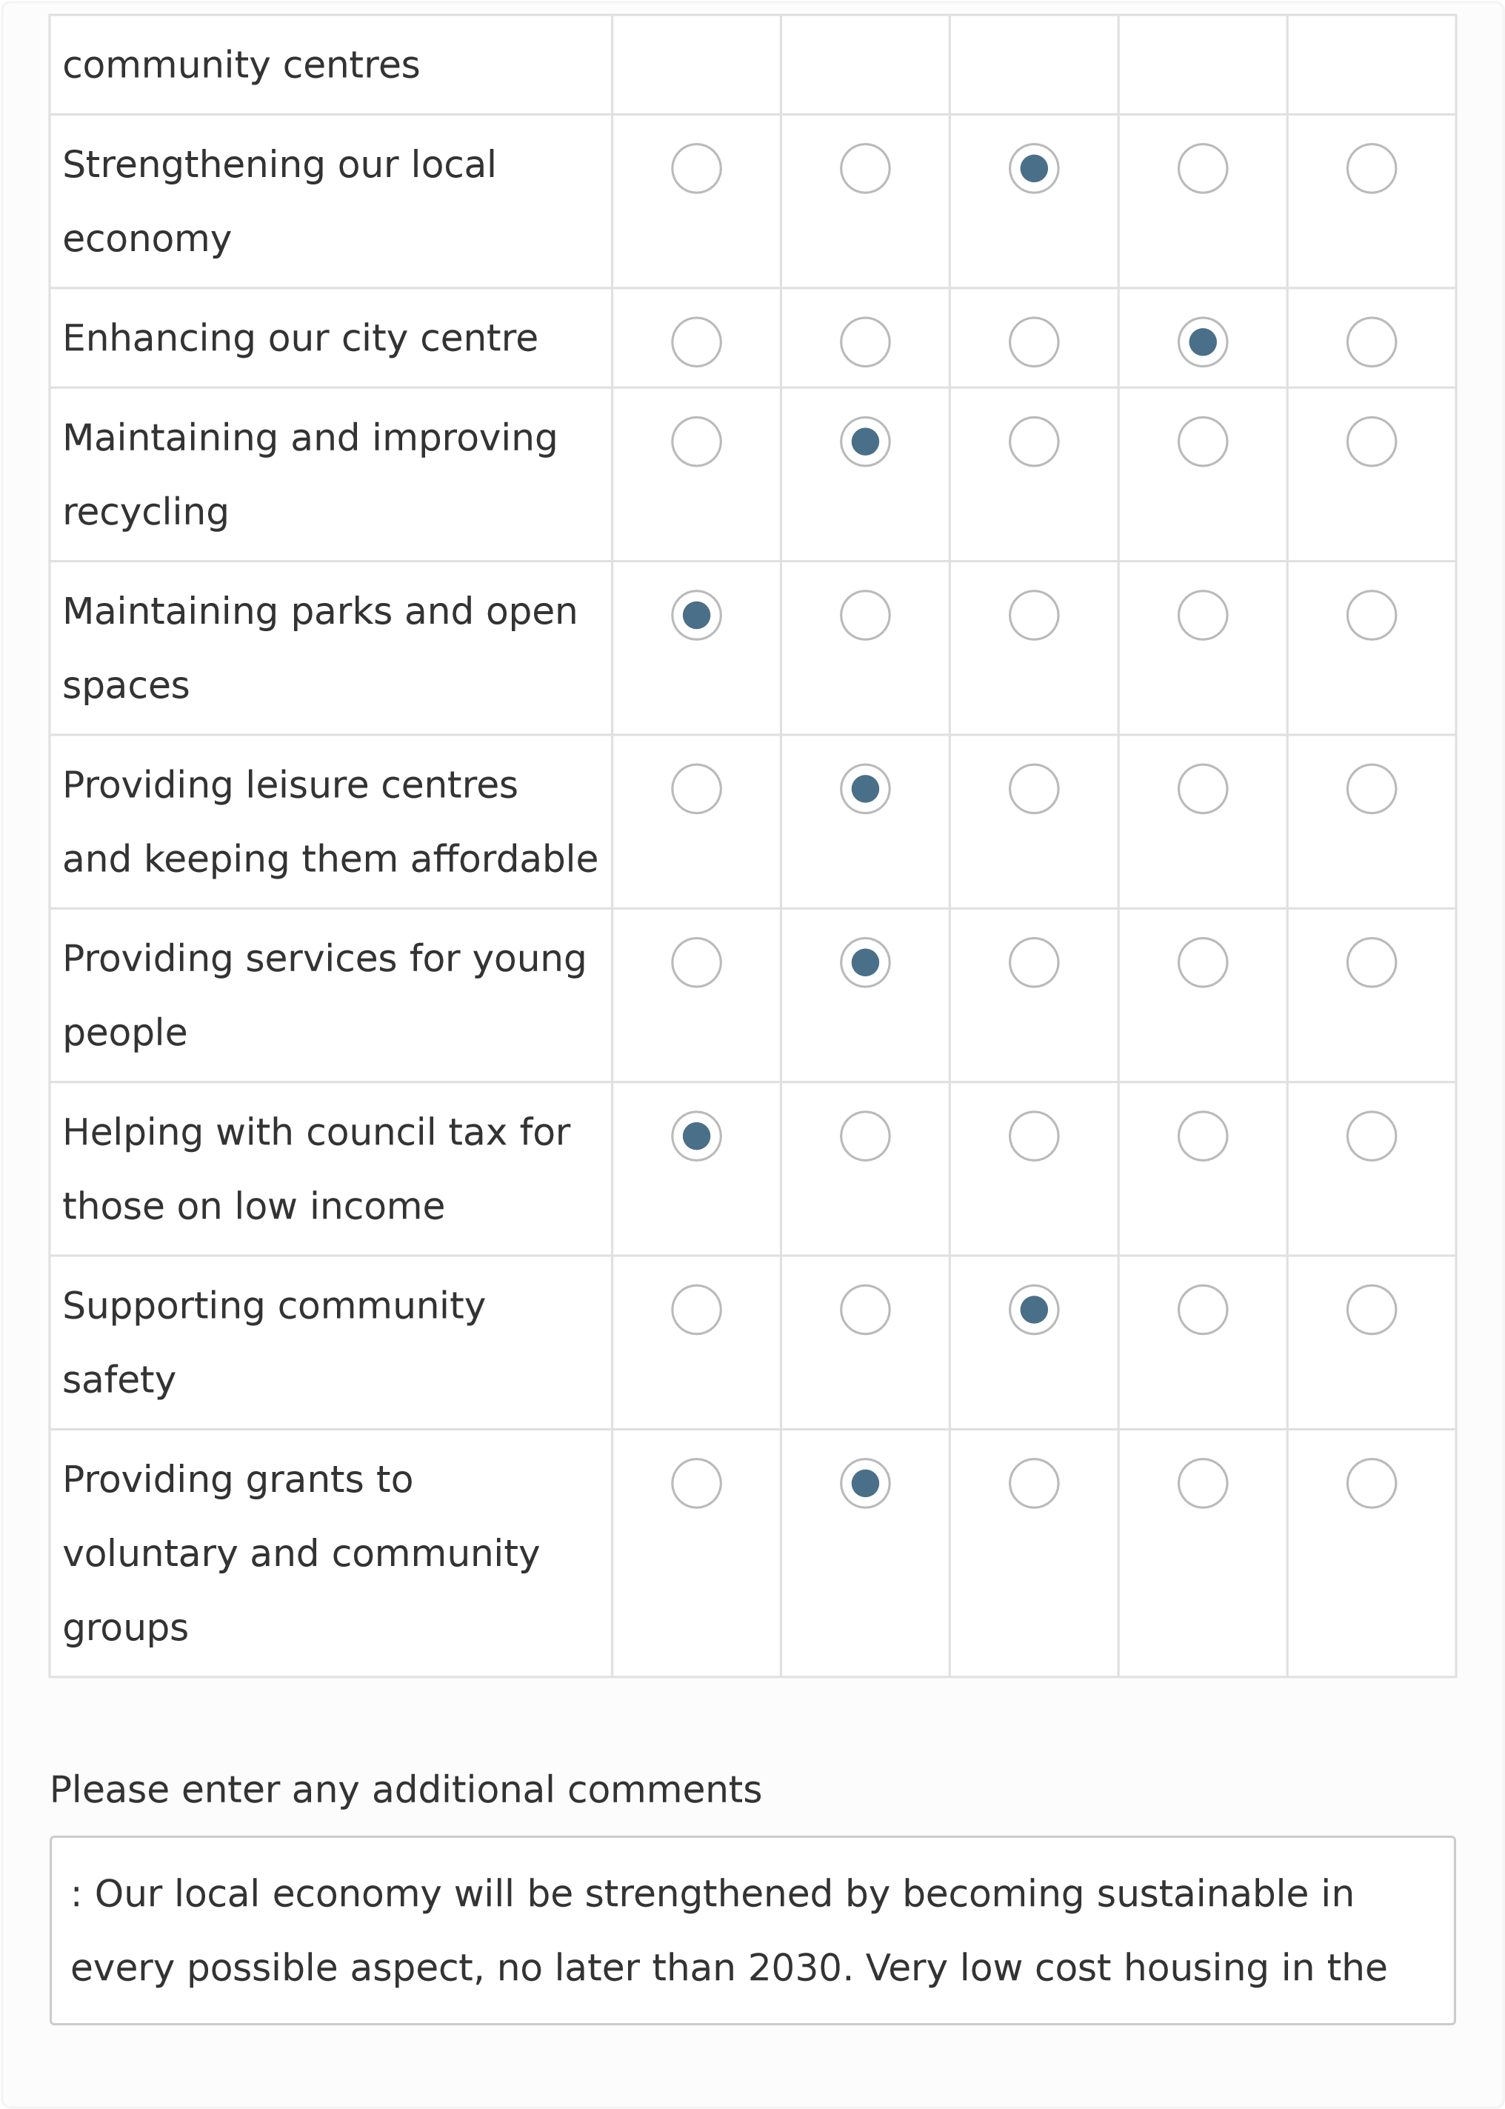
form of social housing means that households will retain more income
for things like organic food, energy efficient goods, buying bikes etc. This
is good for the local economy as the very high local rents are absorbing
too much of local incomes. Very high private rents & mortgages prevent
people doing more than just survive, and drive people out of Oxford
every year. The addition of energy efficient refurbished homes as social
and keyworker housing is of great value to the local economy, as the
proportion of private rented homes is decreased over time.

5
Capital Investment
The Council’s capital investment programme over the next four years
totals £314 million. Some of the more significant schemes are detailed
below.

To what extent do you agree or disagree with the
following

schemes:
Select the most applicable option in each row.

Strongl
y Agree
Agree
Neutral
Disagre
e
Strongl
y
Disagre
e
Covered market
refurbishment £2.2 million
New hardware and software
Information and
communication technology
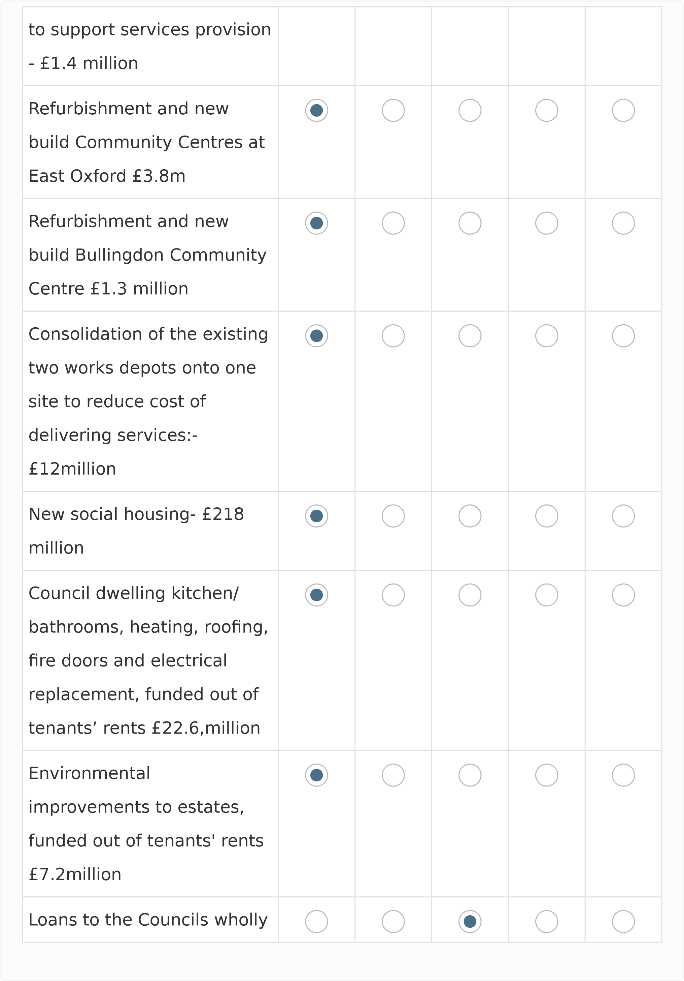
owned Housing
development company
(
OCHL) to deliver market
and affordable housing -
£152 million
Blackbird leys Regeneration
-
for the development of
affordable and market
housing, community centre,
replacement shops and
associated infrastructure -
£21 million contribution
Please enter any additional comments
No investment without sustainability testing, using a wide variety of
indicators about local sourcing; minimal or nil environmental impacts;
boosting local businesses etc. Reduction in parking spaces in new and
refurbished developments, and more car free developments with
enforcing covenants. This can lead to higher density social housing, and
more space for community facilities. Nothing should be built which
requires fossil fuels when in operation.
6

Council Housing
Over the coming years of the Medium Term Financial Strategy we will
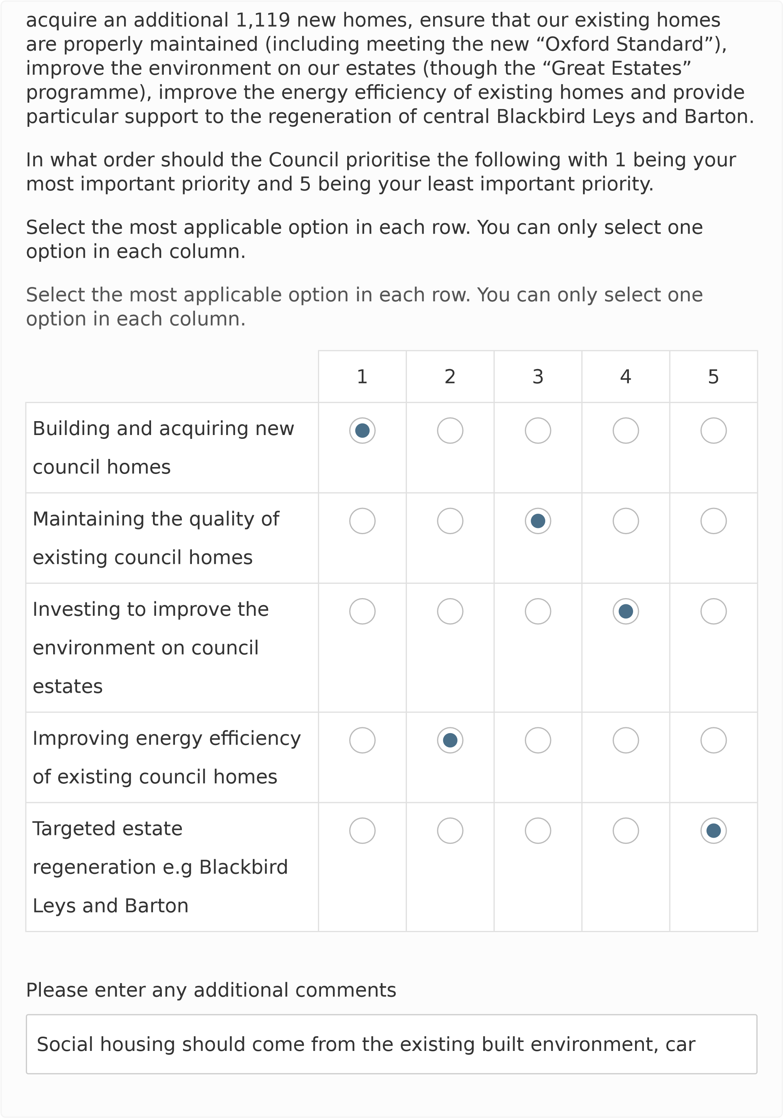
parks and brownfield sites. It should be passivhaus standard as a minimum.
7

Neighbourhood Community Infrastructure Levy (NCIL)
The Community Infrastructure Levy (CIL) is a planning charge, introduced by the Planning Act 2008, as a tool for local authorities in England and Wales to help deliver infrastructure to support the development of their area.
Some of the money gained by CIL will be passed on to local communities where the development is built. This in known as Neighbourhood CIL. In line with CIL regulations 15% of CIL received in unparished areas of the city, which do not have an adopted neighbourhood plan, are retained by the city council for allocation. This money is for the provision, improvement, replacement, operation or maintenance of infrastructure; or anything else that is concerned with addressing the demands that development places on an area.
The City Council currently allocate £5,000 annually to ward councillors not within a parish or neighbourhood plan area. The ward councillors then allocate this on projects that they identify through ongoing engagement with their communities. This approach and allocation will continue. In addition, we are consulting as part of this budget, on a further allocation of NCIL as outlined in the table below.
To what extent do you agree or disagree with the following options:
Select the most applicable option in each row.
Strongl Agree Neutral Disagre Strongl y Agree e y
Disagre e
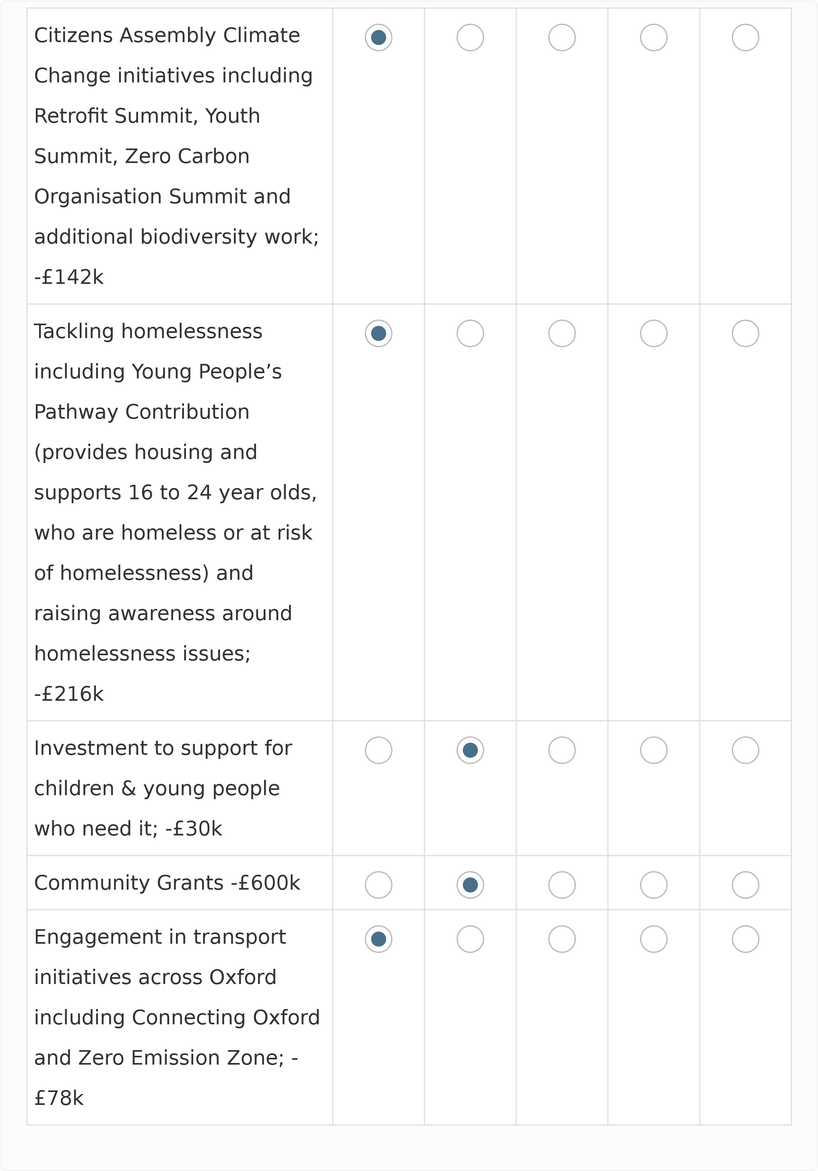
Support for city restart and
economic recovery activity;
£88k
-
Please enter any additional comments
Move the £88k from last option be shared equally between the first
option (climate initiatives) , and the penultimate option (transport
initiatives).
8

Other Comments
Are there any other comments that you would like to make on

Oxford City
Council's draft Medium Term Financial Strategy 2022-25 and Consultation
Budget 2021 -22?
We question the allocation of £53m to commercial property purchase. In
a recession, with Brexit hitting many aspects of the economy including
the use of commercial property, this seems imprudent. Offices are
depopulated by more people working at home, and are a poor
investment; warehousing needs to make much more intensive use of
existing industrial estates-science parks as deliveries by online concerns
continue to increase; online purchasing is radically reducing shops and
commercial rental incomes have been cut back. £53m split evenly
between Climate/ecology policies; social homes bought from those on
sale; and improving active travel with better walking and cycling
networks throughout the City; are all of greater benefit.
ABOUT YOU
The following questions are optional.

By providing us with the
demographic information below, it allows us to understand the background
characteristics of respondents which in turn help us when designing future
services and strategies.
9
.
What is your postcode?
ox3 7hu
10
.
Which of the following best describes how you think of yourself?
Please feel free to provide any further information below.
«No response»
Female
Male
In another way
Prefer not to say
11
.
Which age bracket do you fall into?
16-19

20-24

25-34

35-44

45-54

55-59
60-64

65-74

75+

Prefer not to say
.
12
Which of the following best describes your ethnic group?
White British - English, Welsh, Scottish, Northern Irish
White Irish
White Gypsy or Irish Traveller
Any other white background
Black or Black British - Carribean
Black or Black British - African
Any other black background
Asian or Asian British - Indian
Asian or Asian British - Pakistani
Please feel free to provide any further information below
«No response»
.
13
Are your day-to-day activities limited because of a health problem or
disability which has lasted or is expected to last, at least 12 months?
Asian or Asian British - Bangladeshi
Chinese
Any other Asian background
Mixed or Multiple Ethnic Group - White and Black Carribean
Mixed or Multiple Ethnic Group - White and Black African
Mixed or Multiple Ethnic Group - White and Asian
Any other mixed or multiple ethnic group background
Arab
Other Ethnic Group
Prefer not to say
Yes, limited a lot
Yes, limited a little
No
Don't know
Prefer not to say

